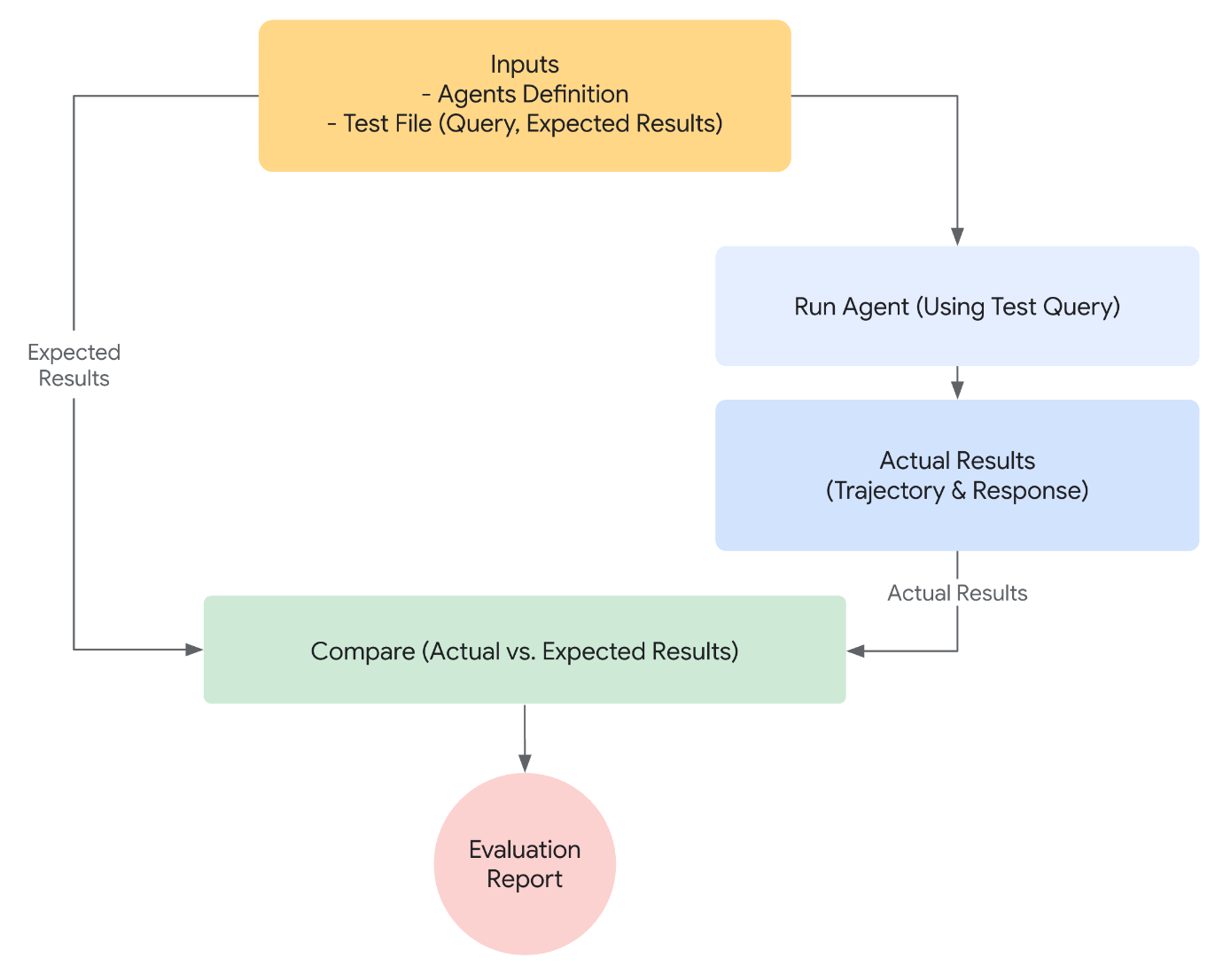
- Define Success: What constitutes a successful outcome for your agent?
- Identify Critical Tasks: What are the essential tasks your agent must accomplish?
- Choose Relevant Metrics: What metrics will you track to measure performance?
{
"criteria": {
"tool_trajectory_avg_score": 1.0,
"response_match_score": 0.8
}
}
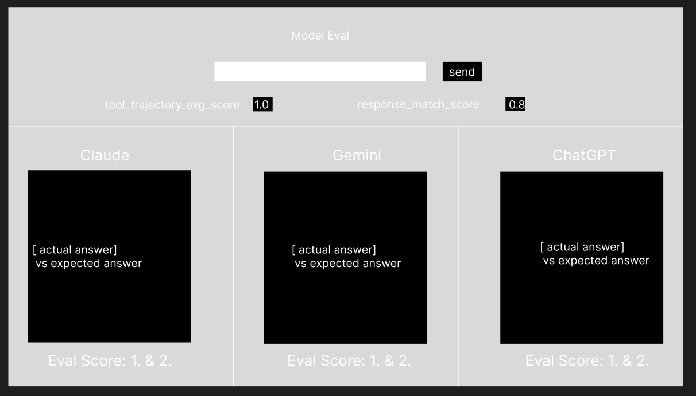

Use judge Ollama + Claude + GPT4
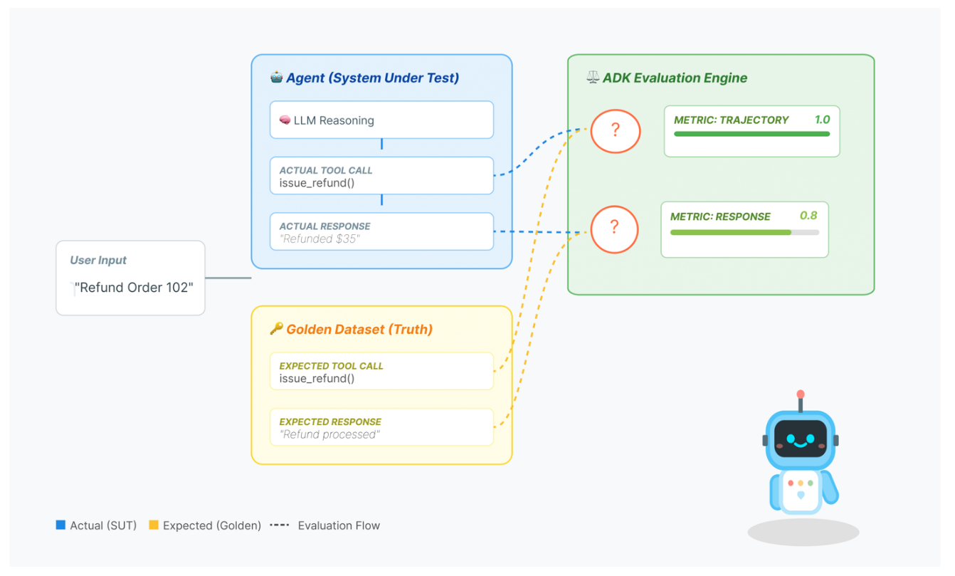
Include use of golden dataset
The golden dataset doesn't need to be perfect. It's just:
- What you/client decided the agent SHOULD do
- The reference point for evaluation
- The baseline for "is this good enough?"

Scoring Metrics
The system tracks two distinct metrics:
- Pass Score (0-1):
  - Definition: A binary-style check. Did the agent satisfy the user's intent?
  - Why: An answer can be "correct" (Pass=1.0) even if it's phrased poorly. This measures functional success.
- Threshold Score (0-1):
  - Definition: A quality/similarity score. How closely does the style and content match the golden answer?
  - Why: This differentiates between a bare-minimum answer and a perfect, high-quality response.

